Project Design Phase - II
Data Flow Diagram and User Stories
Date | 14 February 2026
Team ID | LTVIP2026TMIDS24427
Project Name | HematoVision: Advanced Blood Cell Classification Using Transfer Learning
Marks | 4 Marks

Data Flow Diagram:
A Data Flow Diagram (DFD) represents how data moves through the HematoVision system. It illustrates how input is provided by the user, how it is processed by the system, and how the output is generated and returned. The DFD helps in understanding the system architecture, data processing stages, and interactions between different components.

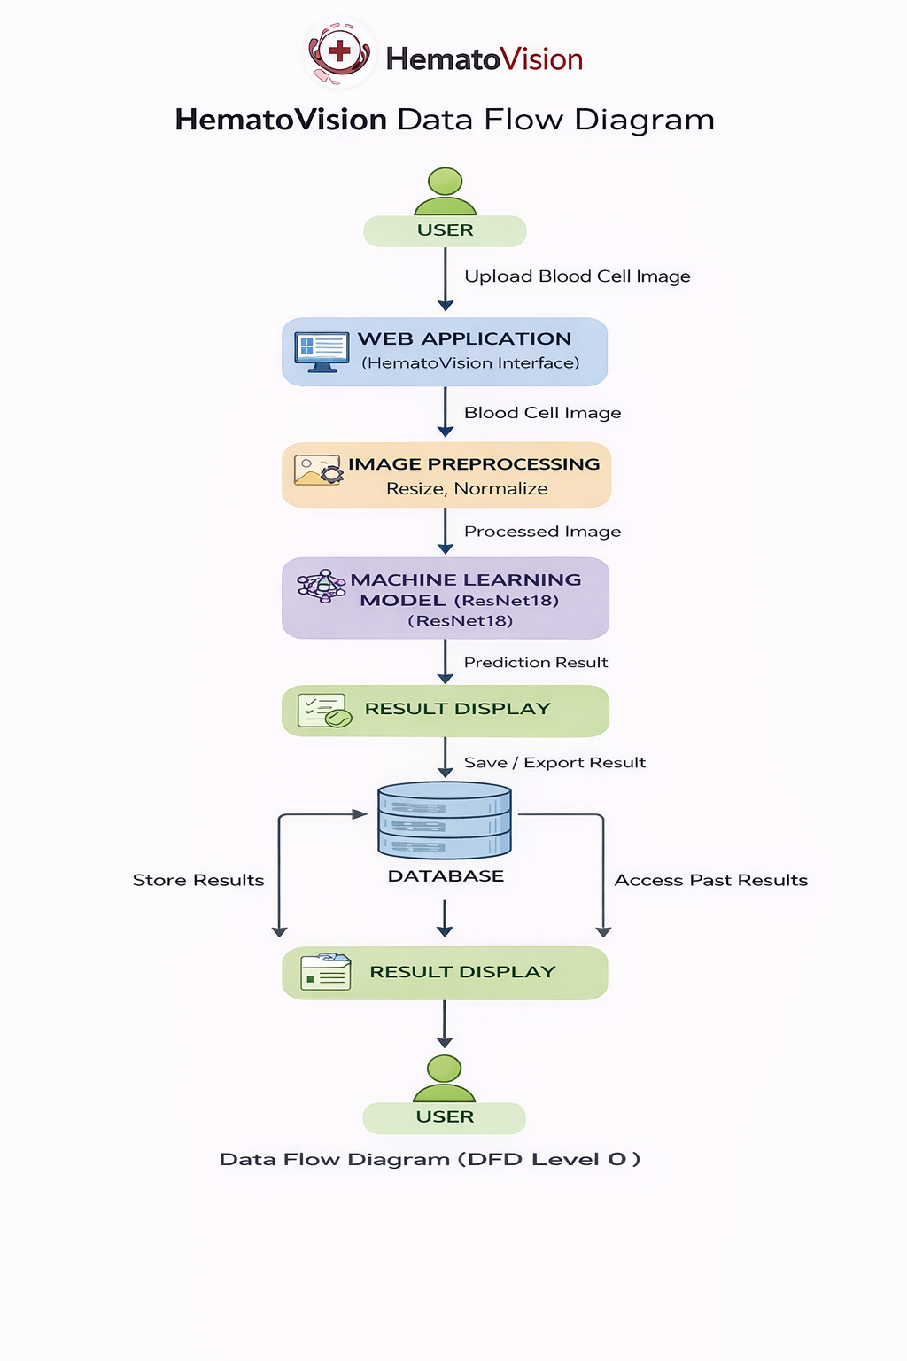
User Stories:
User Type | Functional Requirement (Epic) | User Story Number | User Story / Task | Acceptance Criteria | Priority | Release
User (Web User) | Image Upload | USN-1 | As a user, I want to upload a blood cell image so that I can analyze it. | Image uploads successfully in supported format (JPG/PNG). | High | Sprint-1
User (Web User) | Image Validation | USN-2 | As a user, I want the system to validate my uploaded image to ensure it is a valid blood cell image. | System shows error message for invalid image formats. | High | Sprint-1
User (Web User) | Image Preprocessing | USN-3 | As a user, I want the system to automatically preprocess the image before prediction. | Image is resized and normalized without user intervention. | High | Sprint-1
User (Web User) | Prediction | USN-4 | As a user, I want the system to classify the blood cell image into correct category. | System displays correct predicted class. | High | Sprint-1
User (Web User) | Confidence Score | USN-5 | As a user, I want to see the confidence score of the prediction. | Confidence percentage is clearly displayed. | High | Sprint-1
User (Web User) | Result Display | USN-6 | As a user, I want a clear and simple result page showing prediction details. | Result page shows class name, confidence, and summary. | High | Sprint-1
User (Web User) | User Experience | USN-7 | As a user, I want a simple and clean interface to use the application easily. | Interface is responsive and easy to navigate. | Medium | Sprint-1
User (Web User) | Error Handling | USN-8 | As a user, I want to receive proper error messages,if something goes wrong. | System displays meaningful error messages. | Medium | Sprint-1
User (Web User) | Reuse System | USN-9 | As a user, I want to upload multiple images for repeated analysis. | System allows multiple predictions without reload issues. | Medium | Sprint-2
Administrator | Model Integration | USN-10 | As an administrator, I want to integrate the trained ML model into the system. | Model loads correctly and performs prediction. | High | Sprint-1
Administrator | Model Update | USN-11 | As an administrator, I want to update the model with improved versions. | New model replaces old model without system crash. | Medium | Sprint-2
Administrator | Performance Monitoring | USN-12 | As an administrator, I want to monitor model accuracy and performance. | Admin dashboard shows accuracy metrics. | Medium | Sprint-2
Administrator | System Maintenance | USN-13 |  | System logs stored and accessible securely. | Medium | Sprint-2
  As an administrator, I want to maintain backend server and database logs.

